David Padilla
David.padillajr@gmail.com
The rules and regulations for the fire muster. Interpretation
will be left to the discretion of the judges.
2018 FIRE MUSTER RUles
United Yuma Fire Fighters Association

- A meeting of all Team Captains, Judges and the director will occur no later than 30 minutes prior to the start of competition. The purpose of this meeting will be to ensure everyone involved understands the rules, and code of conduct; to make any special arrangements and to hold the drawing for team positions.

- Prior to the start of each event, only competing team members and the Judges are allowed on the competition field. A two (2) second penalty shall be assessed for each infraction. Other team members may help set-up or break down an event.

- The Team Captain will be the only team member authorized to make a protest to the Event Judge.
3.1- any protest must be made immediately upon completing event.
3.2- Protest can be made if any factor outside of the team control, effects the completion of the event. Falls, stumbles do not necessarily qualify for protest.

- Prior to the start of each event, it shall be the responsibility of the Team Captain to check and ascertain that all equipment is ready and prepared for the event. In case of uncontrollable equipment malfunctions (breakage or failure), not due to team error, a restart will be granted without penalty.

- All protective gear worn must have no modifications. All protective gear must be approved by the judges.

- No equipment shall be broken down until the Event Judge gives the signal to do so. Any infraction of this rule shall result in a two (2) second penalty for each infraction

- All nozzles and appliances must be placed on the ground, not thrown or intentionally dropped; any infraction of this rule will result in a two (2) second penalty for each infraction. Keep contact until it hits the ground.

- A false start shall result in a two (2) second penalty being assessed and the event shall continue. A false start shall be defined as any starting before the Judge gives the signal.

- All events will have a minimum of three (3) judges; two judges will carry official stop watches.

- In case of a 1st, 2nd, or 3rd place tie in any single event, those teams tied shall compete in the event again. The times of their second run, will only be used to break the tie and will not replace their original time.

- Any unsportsman like conduct from any team member shall result in a ten (10) second penalty being assessed to that team at the discretion of the Judges. A second infraction at the same event will result in the addition of 1 minute to a team’s time. A third infraction will result in the team being disqualified.

- The scores will be kept, recorded, and the points will be awarded in the following manner: in each event, One (1) point will be awarded for each team in the competition, i.e., if there are fifteen (15) teams, 1st place will receive fifteen (15) points and last place will receive one (1) point. The overall winner will be the team with the highest total points from all events.

- Penalties not otherwise specified will be two (2) seconds.

- The targets (cones) will be placed on foam buckets.

- All hose will be 2 ½ in diameter.

- Smooth bore nozzles will be used for all events

- All events will count towards total points. With the exception of the Truck pull, the truck pull will be used for a final tie breaker. This only applies if two teams tie for points for the Grand champions.

- There shall be four (4) team events not including the Truck Pull.

- Each team is required to pay in full $125 dollars, prior to the start of the event. Any team who has not paid in full will be disqualified.

This is a NON-PROFIT organization.

Make and Break
Objective: To connect 200 ft. of hose establish a water supply, knocked down a target, disassemble the hose and return to the starting line.
Equipment:
- Each team shall be supplied with 200 ft. of 2 ½ hose.
- Each team shall be supplied with 1” smooth bore nozzle.
- A portable hydrant with wrench permanently attached.
Procedure:
- All six members shall start from a seated position.
- Upon starter signal, team will pick up rolled hose and carry it to the course. Crew benches or chairs must be removed after team has started competition
- The team will unroll the hose and couple them.
- The hose must be connected to the portable hydrant and the nozzle will be connected to the opposite end of the hose.
- The hose is then pulled down the course to the nozzle line as one of the members turns on the hydrant.
- The team attempts to knock over the target (cone).
- After the target is knocked over the team shuts down the hydrant, takes off the nozzle and uncouples each hose coupling.
- The team races back toward the start/finish line with the nozzle.
- Time stops when the last member crosses the start/ finish line.
Penalties:
- Disqualification- abandoning control of the nozzle prior to shut down.
- Disqualification- mid-air unrolling of hose.
- 10 sec penalty- hydrant not fully shut down.
- 5 sec penalty- for each coupling not broken down.
- 5 sec penalty- if the nozzle crosses over the nozzle line.
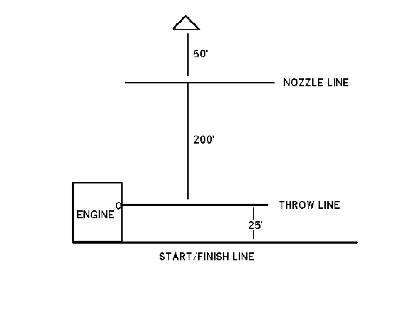
- 5 sec penalty- if the nozzle is not returned to the finish line.
Course:

Bucket Brigade

Objective: to transport 50 gallons of water 24 feet in the fastest time

Equipment:
- Dip tank
- Dump tank
- Six round bottom buckets
- Mechanical signal to completion
Procedures:
- Team members assume the position between the dip tank and dump tank
- Team members must stand facing each other in alternating manner, holding their bucket.
- Time will begin with the member closest to the dip tank (dipper) dips their bucket into the water.
- Team members must pass the buckets from one member to another utilizing a hand-to-hand method.
- Members are not permitted to fill their own buckets and run between tanks.
- Time will end when the ping-pong ball exits the tank.
Disqualification:
- If in the opinion of the course official, excessive slapping of the bucket occurs the responsible team may be disqualified. Three warnings will be issued, prior to disqualification.
- Intentional throwing of water will result in disqualification.
Course:
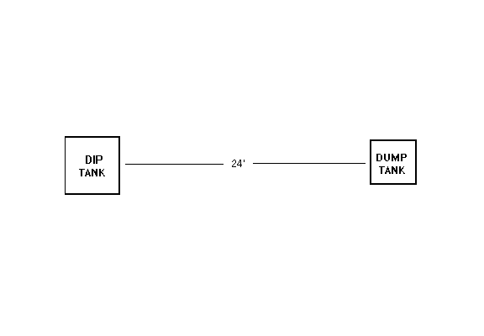

Hose Cart
Objective:
To transport a hose line utilizing a hose cart, make a connection to a nozzle and water supply. Team members will knocked down a target.
Equipment:
- Hose cart- any reel type hose cart may be used, as seen in circa 1900 fire apparatus catalogs as per the following description:
  - The frame may be wood, metal or both. The tongue or drawbar may be modified to provide better pulling power.
  - The wheels may be wood, metal or both. There will be no pneumatic tires
  - No ball or roller bearings will be allowed.
- 200 ft. of 2 ½, double jacketed. A minimum of 190’ of 2 ½ hose must have water passing through for this event. Hose strap are optional. Couplings must be 2 ½ NST. No quick connect couplings will be allowed.
- Nozzle pressure will present 60 p.s.i.
- No part of the apparatus used for pulling the cart shall be affixed to a team member in a manner that prevents immediate release. No wrapping rope around wrist. If rope is used, no loops are allowed.
- Nozzle with a 1 inch tip
- Target
- Hydrant
Team:
Team will consist of six members per hose cart assigned as follows
- Two members on the nozzle
- Two on the hydrant
- Two on solid handle pull and to stop cart

Only the six members of the running hose cart team and officials are allowed on the course during the event (no pacers). All team members must be adults (18 and over). All participants competing are doing so at their own risk.
Procedure:
- On signal from the start (time will start) team will pull hose cart a distance of 100 ft. to the nozzle line (area will be marked).
- Nozzle with 1’ tip and a shut off valve will be located at this point; where the two persons of the team will drop off; holding onto the male end of the hose.
- The hose cart and the rest of the team continue to the hydrant.
- At the hydrant two more members will drop off and one going to the hydrant and the other to the hose line. The member with the hose line will connect to the hydrant.
- After making the connection, the water is turned on.
- The hose cart is completely stopped before the last two members release the cart
- The nozzle man will knock down the target and the time will stop.
  - The hydrant will have the cap off and wrench on, hydrant may be on either side of the course.
  - Nozzle and tip will be provided by the hosting fire department and must be used by all teams.
  - Target will be placed on a five-gallon bucket or similar platform. The nozzle is directed at the target until it falls and time will stop.
Penalties:
- 5-second penalty- for extending the nozzle beyond the line when nozzle has water.
- 5 second penalty- if two people are not on the nozzle when water reaches the nozzle
- 10-second penalty for failure to maintain full control of the hose.
- Disqualification- for any team who abandons control of the nozzle prior to shut down
- Disqualification- for any team who abandons control of the hose cart before completely stopping it.
- Disqualification – if a team uses less than 190ft of hose
- Disqualification- the use of any top discharge hose loads.

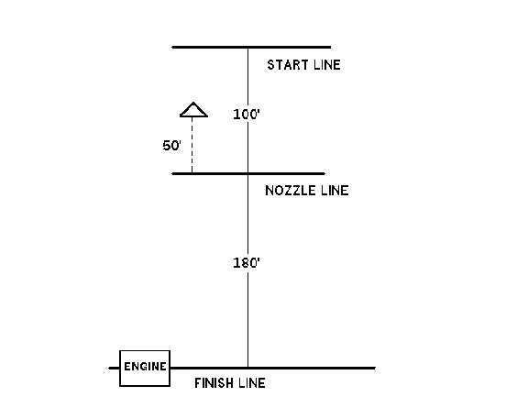

Barrel Squirt
Objective-
Utilizing 2 ½ hose lines each team will compete head to head to push a keg suspended in the air into the other team’s goal.
Equipment:
- 150 ft. of 2 ½ hose.
- 1” straight tip nozzle on their hand line
- Both hand lines will be connected to a water thief or similar appliance. (manned during completion)
Team:
Teams shall consist of six team members. Each member shall hold onto the hose. Each member should be dressed in a helmet with visor down, turnout coat and closed toed footwear. Gloves are optional
Procedure
- Each team will be positioned on their starting marks, next to the pylons with all members holding the hose.
- The barrel will be placed in the dead center of the line.
- The entire barrel must be 10-15 ft. above the ground.
- On signal from the starter, each team will squirt water onto the barrel in an attempt to push it over the heads of the opposing team.
- The team that pushes the barrel over the heads of the opposing team and strikes the stop at the buffer zone wins.
- There is no time limit
- The host organization shall decide if it is single or double elimination.
Penalties:
- Disqualification for any team who intentionally squirts the opposing team with a direct stream of water.
- Disqualification for any team who releases the hand line under pressure while still open.
- Disqualification for any team with a member warned twice about not having their face shields down.
Course:

5 ft. buffer
5 ft. buffer

110 ft.

